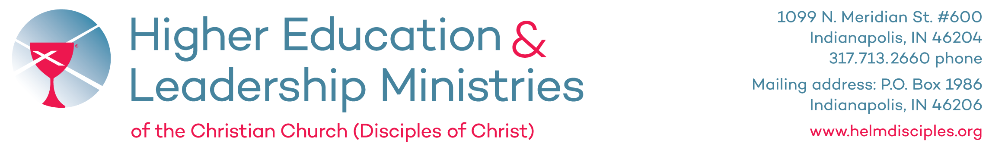

Dear Congregations,

Greetings in the name of Jesus Christ! As we enter this season of Thanksgiving, I hope your congregation will participate in the Disciples Mission Fund Thanksgiving Offering taking place on November 15th and 22nd. The Thanksgiving Offering benefits the colleges, universities and graduate theological institutions affiliated with the Christian Church (Disciples of Christ).

In the midst of national and global challenges associated with the COVID-19 pandemic, our higher education institutions are facing unprecedented challenges and they need our support now, more than ever. Even as they work diligently to ensure safe and healthy learning environments, the financial realities faced by many or our schools is adding additional stress to students, faculty and staff. So while there is much to be thankful for in our schools continuing to meet the needs of students, there is also much work still to be done to ensure they remain financially viable.

The fifteen colleges and universities and the seven theological institutions in covenant with the Christian Church (Disciples of Christ) encourage students in their intellectual pursuits and nurture them as leaders to transform church, society and world. Your congregation’s gift to the Thanksgiving offering helps support these efforts in education and leadership formation.

You will find online the materials to help promote the Thanksgiving Offering on the Disciples Mission Fund website (https://disciplesmissionfund.org/special-offerings/thanksgiving/). The gifts received are an investment in our students and the work of our schools, and we thank you for your participation and continued support.

Sincerely,

Chris Dorsey, President
Higher Education & Leadership Ministries

Enclosures

