February 2019
Dear CHURCH NAME:
As I reflect on the past year, I am grateful for the work we pursued together. As our congregations, regions, and ministries serve our unique and changing communities, I am mindful of all the ways in which we are united.
Giving to Disciples Mission Fund (DMF) is one of the most important ways we unite around our shared vision. Our gifts represent us in the work that cannot be completed alone. Your trust in Disciples’ regional and general ministries is meaningful because it makes our work together possible.
Your support of Disciples Mission Fund, through budgeted gifts and Special Day Offerings, sustains your regional ministry and dozens of other ministries across the life of our Church.
One of the powerful stories we shared this year, through Disciples News Service (supported by your gifts to DMF), was about an Arizona church. Upon closing, its remaining members worked with their regional ministry and the Disciples Church Extension Fund to create a new ministry and mission center to care for their community. Your gifts make this kind of creative collaboration possible.
Because of you, Disciples students also receive educational scholarships through Higher Education and Leadership Ministries (HELM), and the 14 Disciples-related colleges and seven theological institutions.
Thanks to your participation in our shared vision, the Disciples of Christ Historical Society preserves our Church’s legacy and that of the wider Stone-Campbell movement. Our Church is also growing and evolving, with your support, through the New Church Ministries as a part of Hope Partnership for Missional Transformation.
Your gifts to Disciples Mission Fund connect your congregation to these ministries and more. Thank you for sharing our vision and for making our work possible.
With deep gratitude for your generosity,
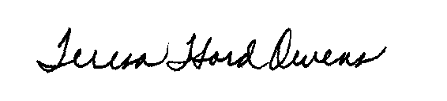
Rev. Teresa “Terri” Hord Owens
General Minister and President of the Christian Church (Disciples of Christ)
To make a gift online, or to find an electronic version of this letter to use in your congregation’s publications, visit disciplesmissionfund.org. Turn this letter over to review your congregation’s giving report.
Mailing: PO Box 1986, Indianapolis, IN 46206-1986
Street: 1099 N. Meridian St, Ste, 700, Indianapolis, IN 46204
Telephone: 317.635.3100 ∙ Web: www.disciplesmissionfund.org
Teresa Hord Owens
General Minister and President

