Winter 2018
Dear Church:
As I reflect on the past year, I celebrate the many ways that we have served our God together. We have worshiped and prayed together, and formed partnerships in our communities. Though we Disciples are spread out across the United States and Canada, one of the ways we stay connected as one body is through our gifts to Disciples Mission Fund (DMF).
I thank your congregation for supporting our Church’s work. By contributing to DMF, you are sustaining 72 ministries of wholeness from your region to partners around the world.
Your generosity connects you to our shared heritage, through supporting the archival and educational work done by the Disciples of Christ Historical Society in West Virginia, working to ensure that the traditions and connections we cherish can inform generations to come.
DMF connects you to the life-giving ministries of your region, from leadership training for ministers to church camp programs for youth. A group of Illinois Disciples recently reunited, 50 years after they first met at church camp. Hearing about their joyful, reflective time together reminds me of the long-lasting impact that our regional ministries have on those who participate.
Your congregation’s gifts to Disciples Mission Fund connect you to the wider Church through the resources you make possible. Your support allows programs in the Office of General Minister and President, like the Center for Faith and Giving and Communication Ministries to serve the whole Church, through curriculum and stories that inspire us to pursue ministry in transformative ways.
Your congregation is connected to these ministries and nearly 70 more because of Disciples Mission Fund. Today, I celebrate your generosity and your love. Thank you for being there when the Church needs you most. Thank you for supporting Disciples Mission Fund.
With deep gratitude for your generosity,
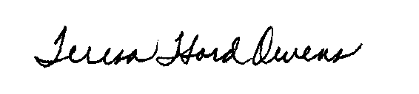
Rev. Teresa “Terri” Hord Owens
General Minister and President of the Christian Church (Disciples of Christ)
To make a gift online, or to find an electronic version of this letter to use in your congregation’s publications, visit disciplesmissionfund.org. Turn this letter over to review your congregation’s giving report.
Mailing: PO Box 1986, Indianapolis, IN 46206-1986
Street: 1099 N. Meridian St, Ste, 700, Indianapolis, IN 46204
Telephone: 317.635.3100 ∙ Web: www.disciplesmissionfund.org
Teresa Hord Owens
General Minister and President

