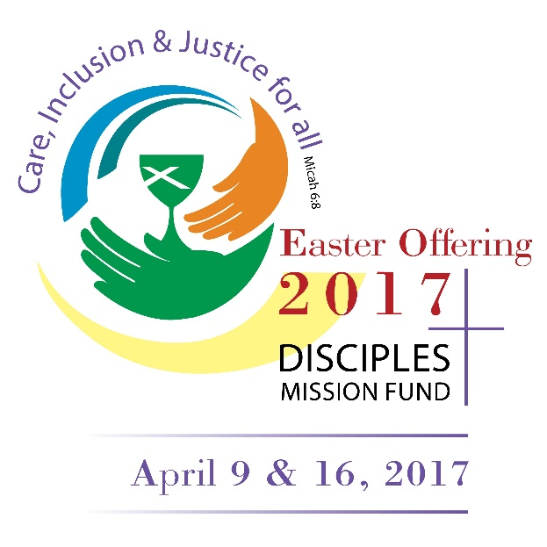
“So God created humankind in his image,
In the image of God, he created them;
Male and female he created them.”
Genesis 1:27

Texas Christian University student Kelsey Cobbs is a junior Religion/Spanish double major. She is the recipient of both the Beasley grant and the CYF grant.

I’m not qualified to write a blog about human trafficking…but I know about it and I know that I am a contributor. I’m not qualified to tell people how to end the global slave trade…but I know that I can educate myself and others. I can strive to reduce how much I contribute to the industry. I gathered with the TCU Disciples on Campus yesterday evening to talk about social justice in response to our Voices campaign. I spoke about human trafficking and how we, as people of God, are called to respond.

The first time I learned about human trafficking was my senior year of high school when I went on International Affairs Seminar with the Christian Church in Oklahoma. Through this seminar, I found a passion for social justice and human rights. I hadn’t been apathetic before, I was simply living in my own world of blissful ignorance. On that trip, the world got more complicated in my eyes.

When I found out that the clothes I wear, the products I buy, and the services I pay for put money in the pocket of the kind of person to whom I would never want to give my money, I knew that a change had to be made. That money goes to a person who uses their power to take advantage of people who are impoverished, young, and/or vulnerable in order to make a profit. These people break the law and diminish the quality of life for people across the globe and in turn, I get cheap clothes, cosmetics, and hygiene products.

However, I am an abolitionist. As a child of God who is called to care for God’s people instead of taking advantage of them, I am an abolitionist. My work as a person of faith includes praying, serving in the Church, and advocating for the rights of other human beings. If we are made in God’s likeness while bearing God’s own image, shouldn’t every person be treated as though the divinity in them is a manifestation of the Divine Herself?

“One bread, one body, one Lord of all, one cup of blessing which we bless.
And we, though many, throughout the earth we are one body in this one Lord.”

The bread and the cup that we share with one another in communion is the same communion that people all over the world share. When we share in divine fellowship with one another, we share in divine fellowship with the people who are being trafficked. This is why it is important for me to learn and educate others of the impact my privilege and place in society impacts those of a lower social standing. I cannot stand by when walking, talking images of God are being exploited in my neighborhood.

And the change starts with me. And also with you.

