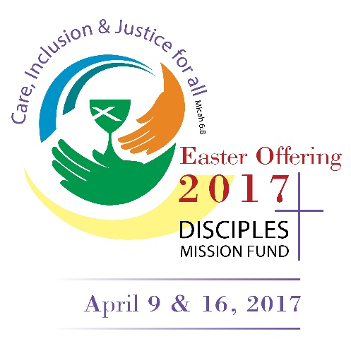
“He has shown you, O mortal, what is good.
And what does the Lord require of you?
To act justly and to love mercy
and to walk humbly with your God.”
To live out God’s Mission in the world as a church we have to understand what is good. It is not enough to act justly and to love mercy, but we also have to walk humbly with God.
One of the ways that we can walk humbly with God, is by accompanying international partners in their ministries – rejoicing in their good news, suffering with their bad news, and holding up the many lessons that they offer the church in North America.
Global Ministries’ Area Initiatives have helped hundreds of congregations to deepen their understanding of world, while providing Bible studies, webinars, and children’s materials that foster deeper relationships with partners and their unique understanding of the challenges and opportunities facing their communities. For partners, the Area Initiatives shares a strong witness that they are not forgotten, even when they face extraordinary challenges like the decades long conflict in the Congo, or the Refugee Crisis coming out of Syria. For congregations, the Area Initiatives provide opportunities to act justly, to love mercy, and to walk humbly with God.
Your gift to the Easter offering helps congregations across the United States and Canada to share more deeply in the work that God is doing around the world.

